Ideation Phase
Brainstorm & Idea Prioritization

Date | 31 January 2025
Project Name
Maximum Marks | 4 Marks

Brainstorm & Idea Prioritization:

Step-1: Select the Problem Statement
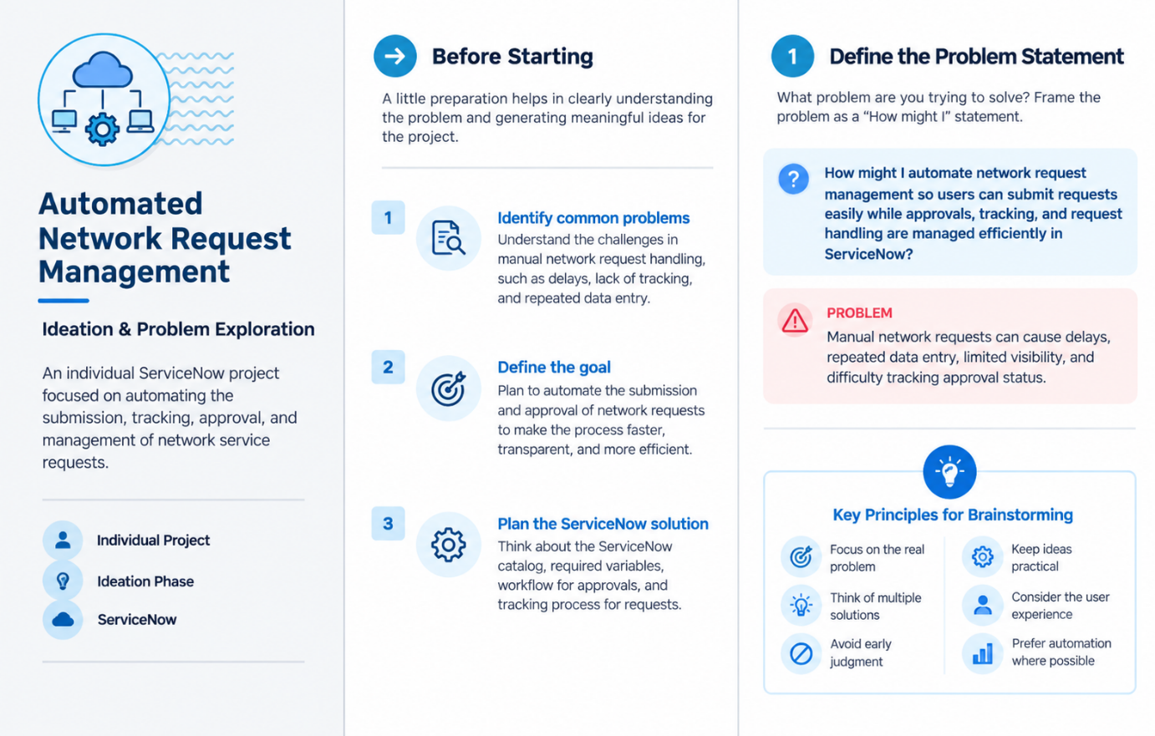

Step-2: Brainstorm, Idea Listing and Grouping:
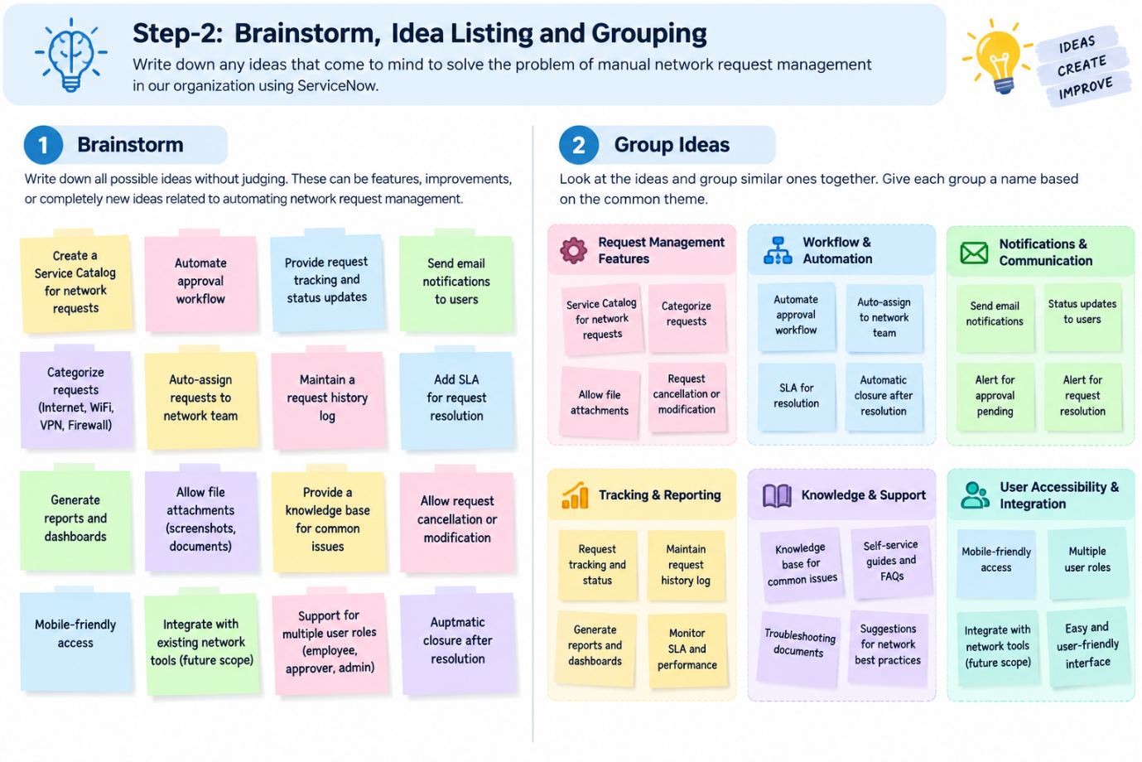Step-3: Idea Prioritization: 